IndyGo IOT Condition Monitoring

Indocosmo Systems Private.LTD
Document Date:23/12/2020

Key Contacts: ARJUN RK
1. Introduction

IndyGo is act as IoT service provider. IndyGo mainly providing HACCP solution to the supermarkets. IndyGo is located in Fukuoka is well known area in Japan.
IndyGo HACCP solution system helping the supermarkets to monitoring freezer and coolers temperature and humidity through IoT devices.

The Internet of Things is one of the most important and promising technological topics today. Some market researchers estimate that there are more than 20 billion connected devices and counting. Around us, there are smartphones, wearables, and other devices, all of which use sensors. Nowadays, sensors play an important role in our everyday life and in IoT. Sensors monitor our health status (e.g. a heartbeat), air quality, home security, and are widely used in the Industrial Internet of Things (IIoT) to monitor production processes. For these reasons, it is important to know how they work and how we can use them to acquire information.

Measuring temperature is one of the most common techniques used because it is important for many operations and tasks to be performed like in any industries where heaters/freezers are used. When it comes to sensing temperature, a temperature sensor is used that is installed at a place whose temperature is to be sensed. The temperature of that place can be monitored through the internet using the internet of things.

The web-based temperature monitoring system that can be accessed anywhere and anytime through the Internet is built. With this system a user can remotely monitor the room temperature from anywhere which could save the human expenses. IoT WebBased Temperature Monitoring is one type of temperature recorder that monitors a temperature in a room and stores the data into a database and displays the current temperature on the website through a web server. The system will continuously monitor the temperature condition of the room and the data can be monitored at any time and anywhere from the Internet.
The main purpose of this system model is to make it easy for the user to view the current temperature.

2. Problem Statement

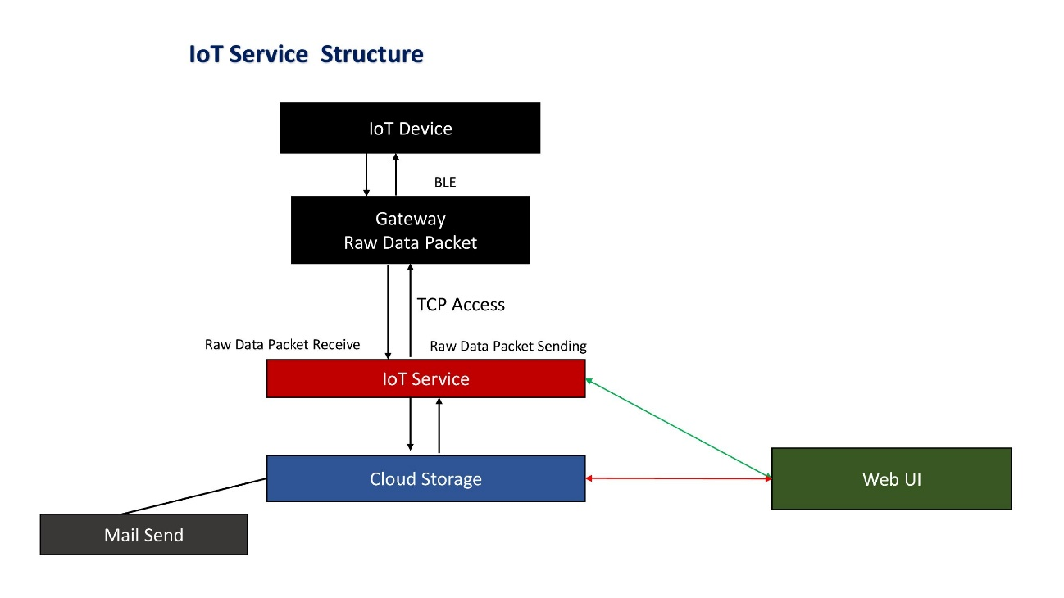

Quick Service Requesting and Closing
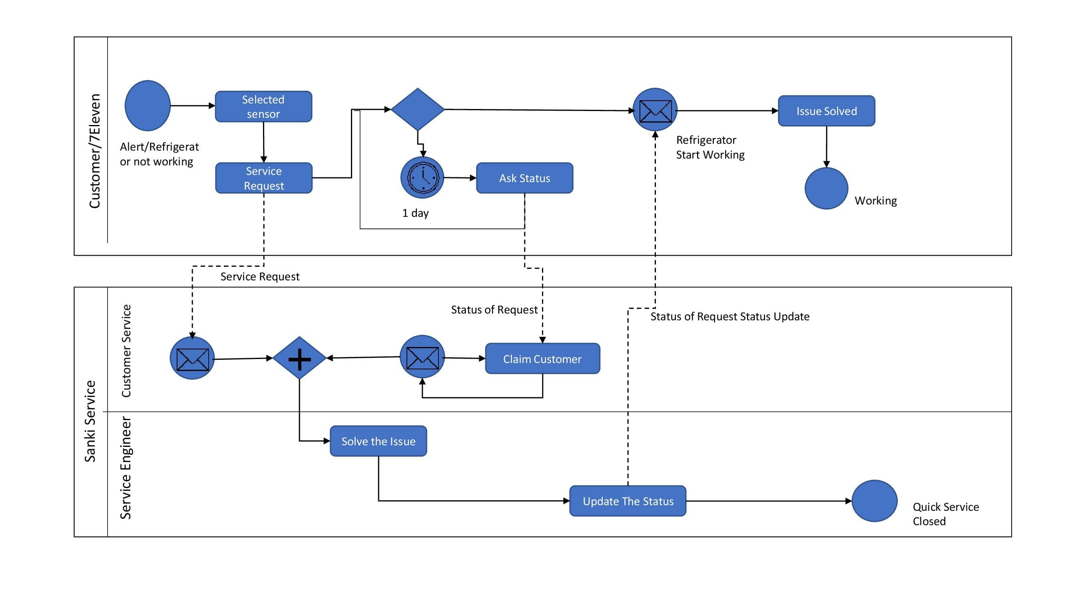

3. Proposed Solution

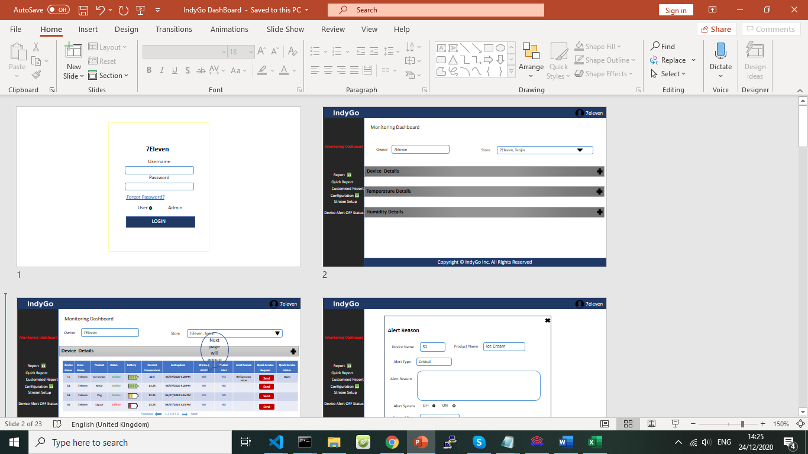
1. Login Page 2. Monitoring Dashboard screen of End user
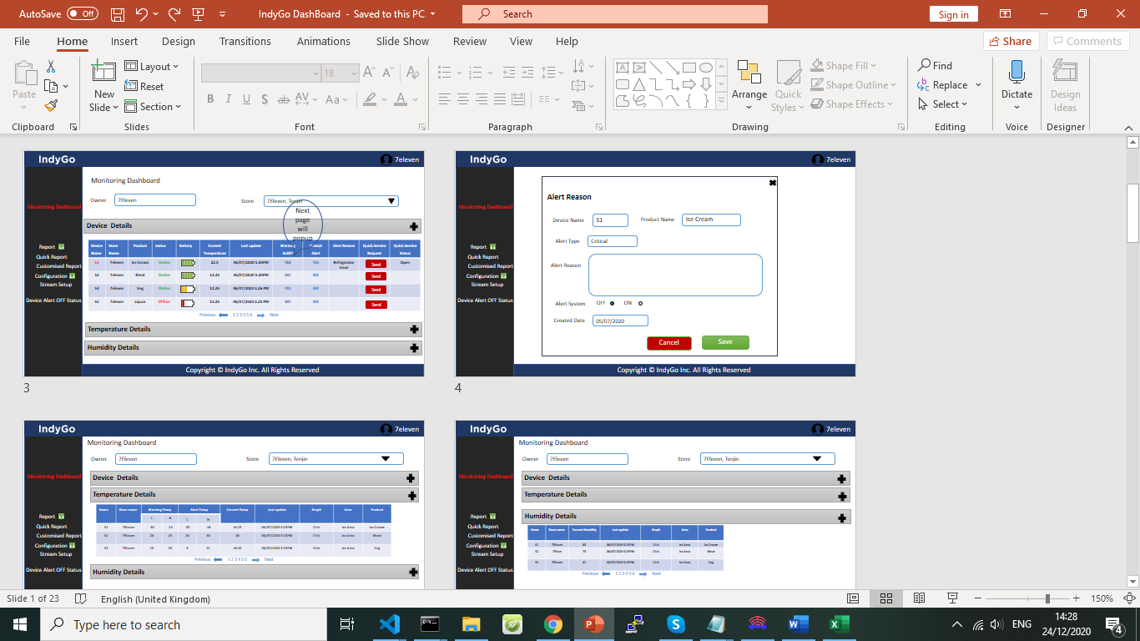
3. Monitoring Dashboard Device details table. 4.Dashboard alert reason and alert off model
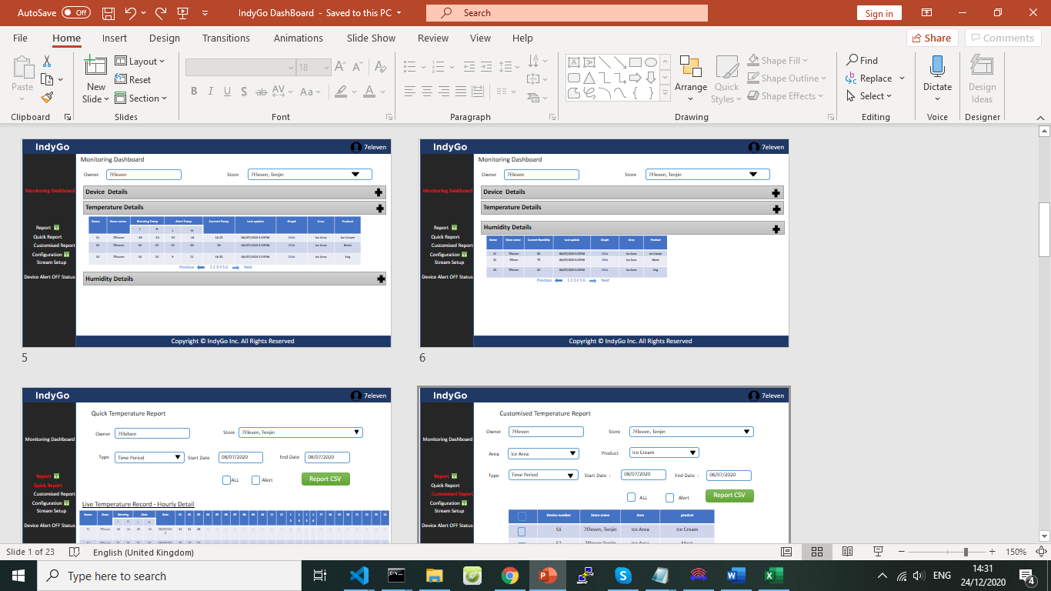
5.Dashboard Temperature details table 6.Dashboard Humidity details table
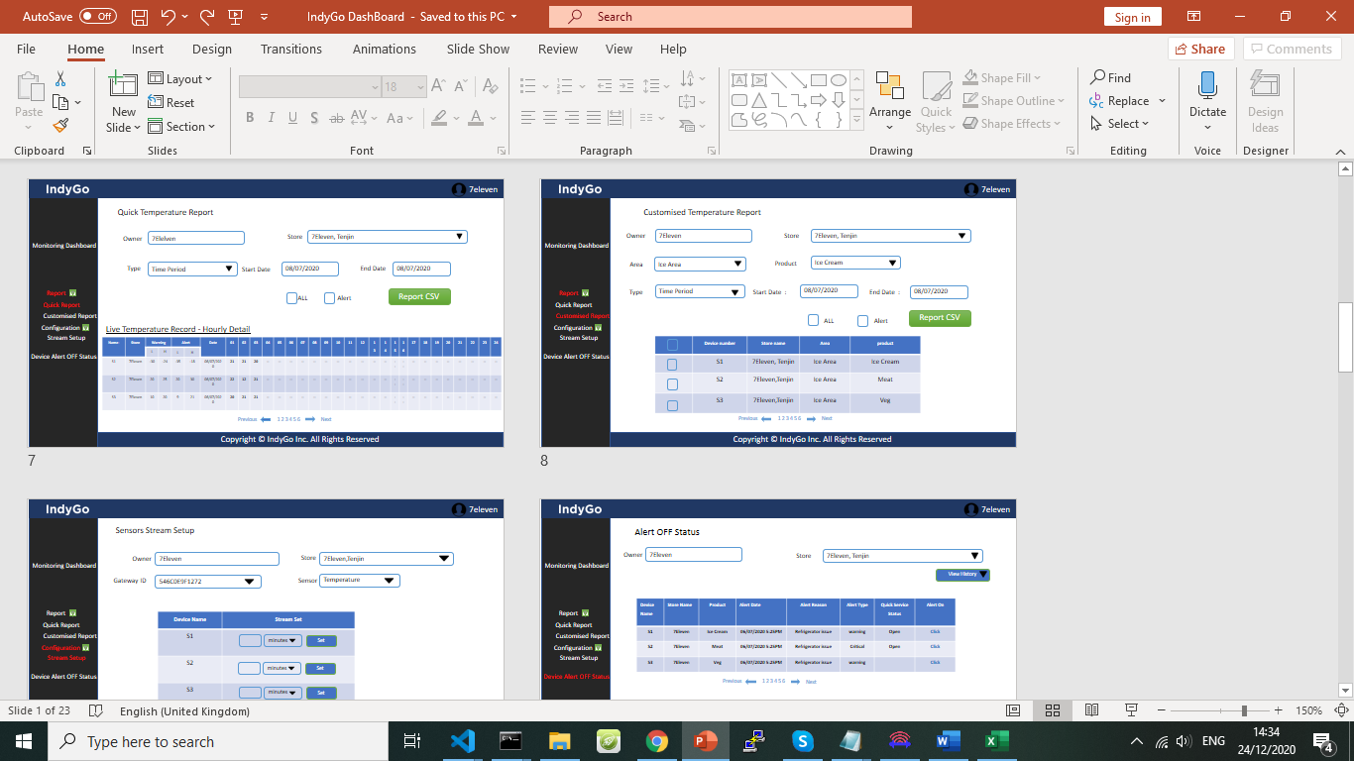
7.Quick Temperature Report 8. Custom Temperature Report
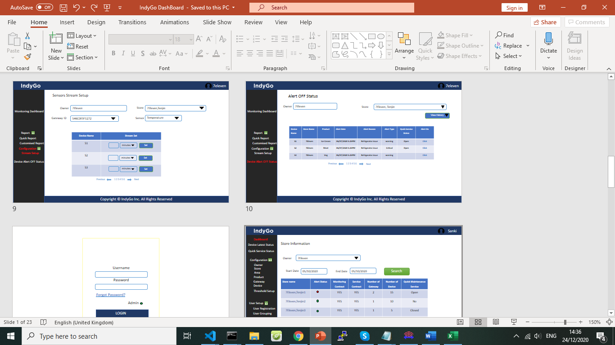
9. Temperature Stream Setup 10. Alert ON service
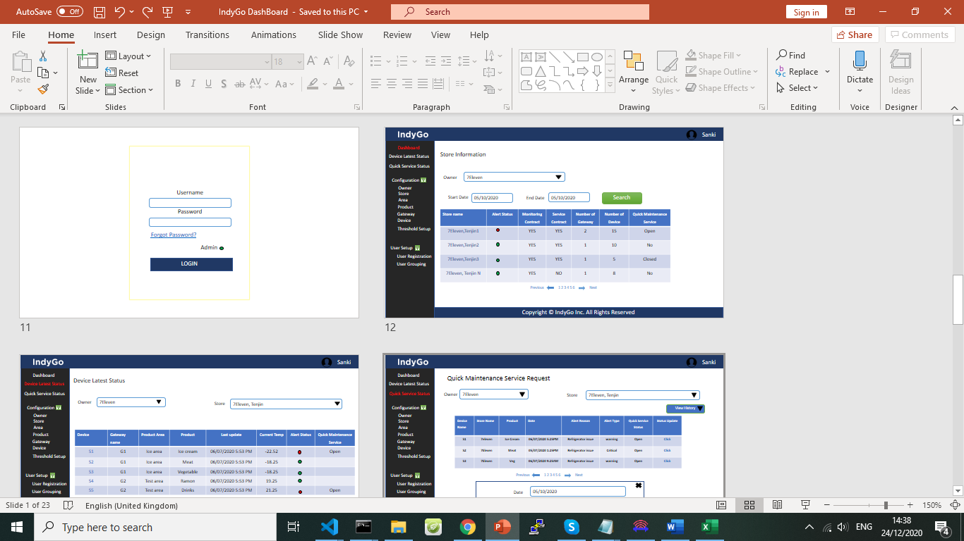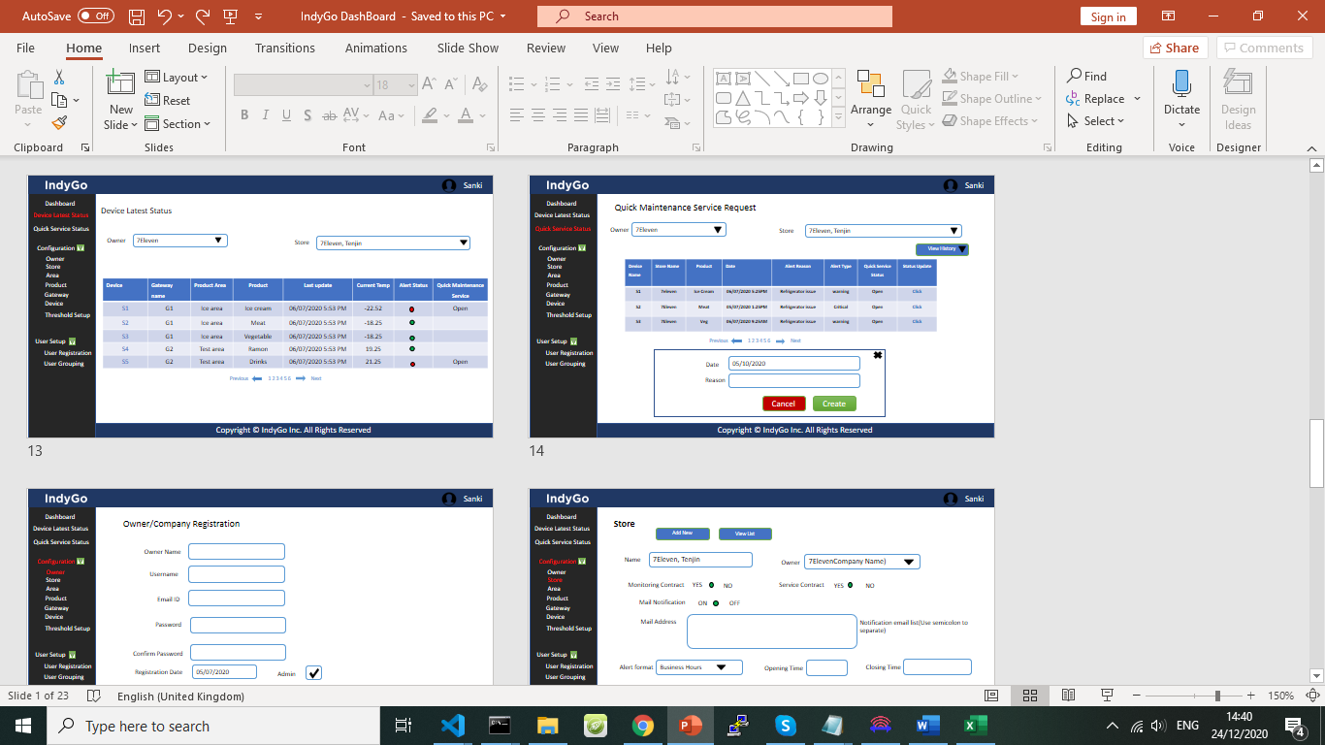
12. Dashboard of Service user(middle user) 13. Latest device (Product) Details
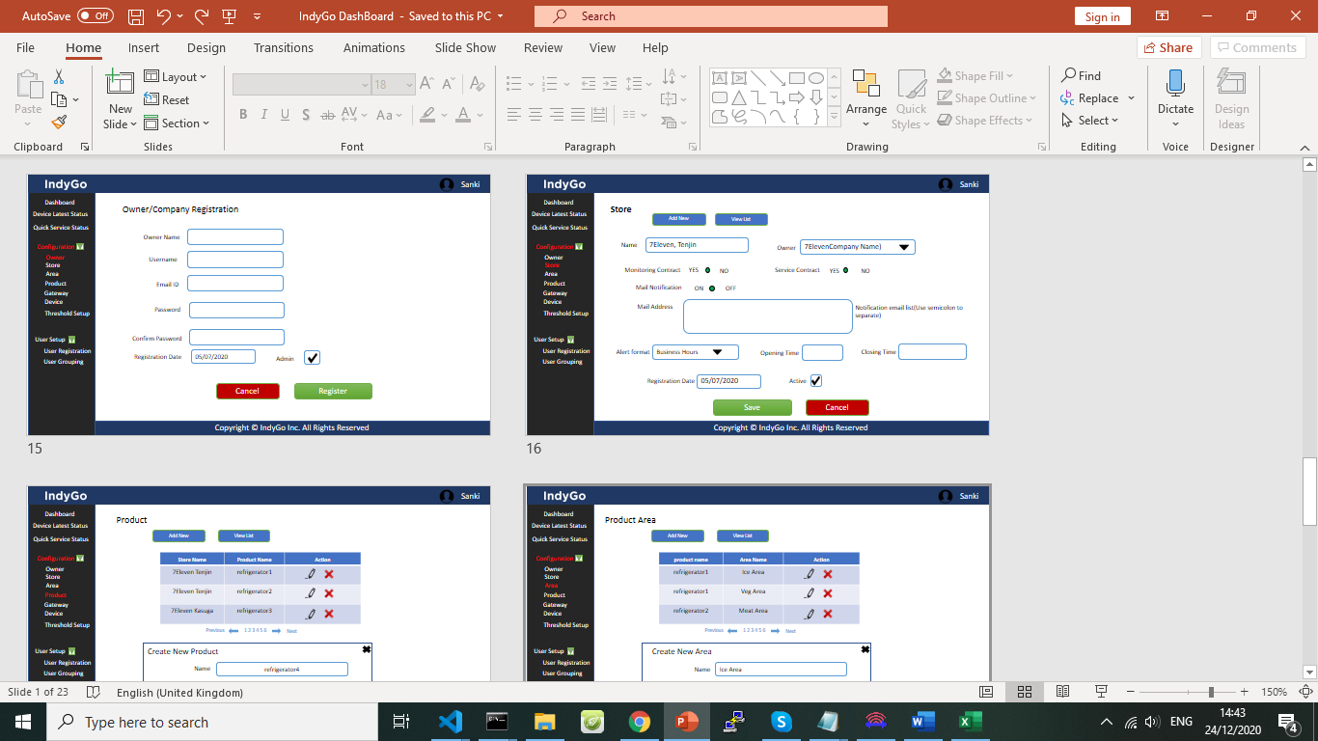
14.Quick Service 15. Company
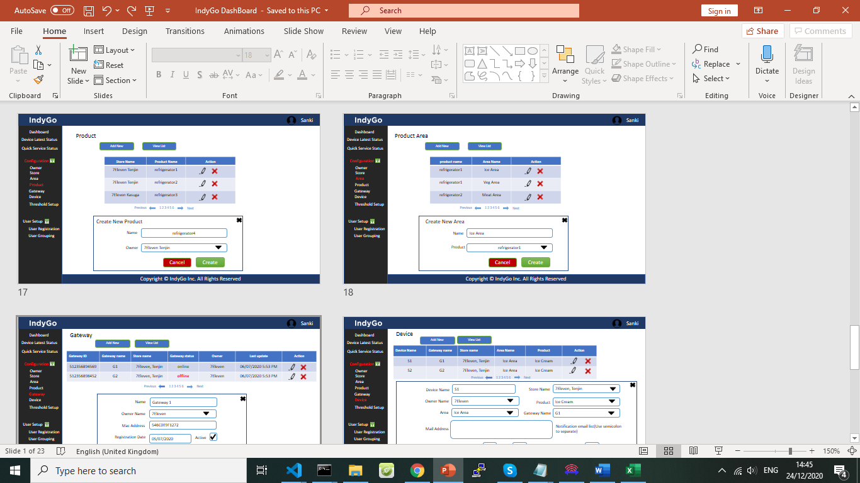
16.Store 17. Product
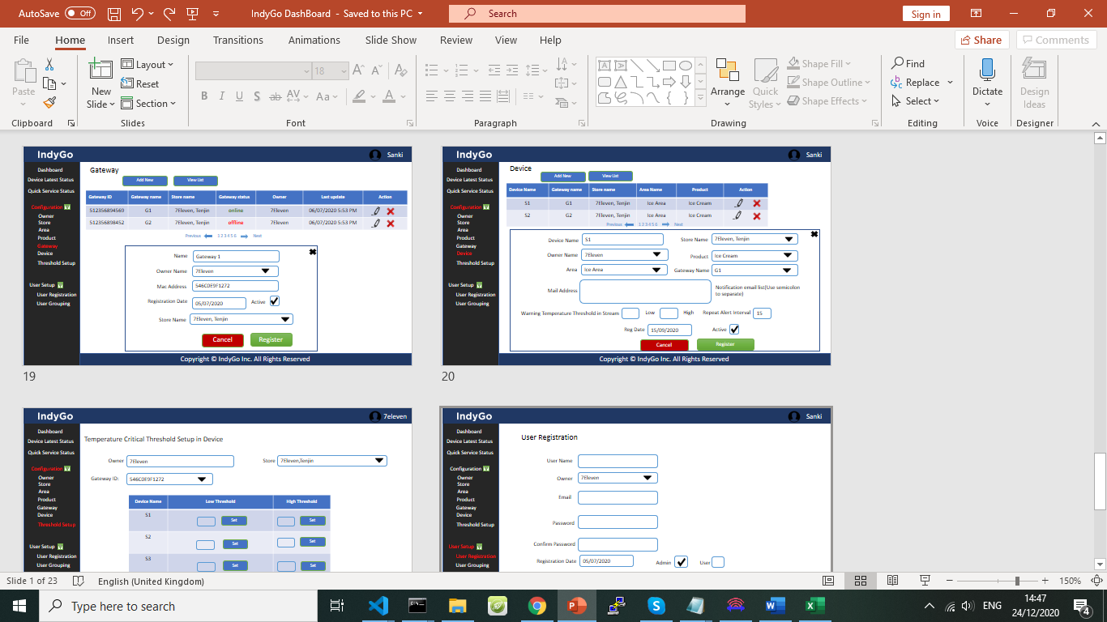
18. Product Area 19.Gateway
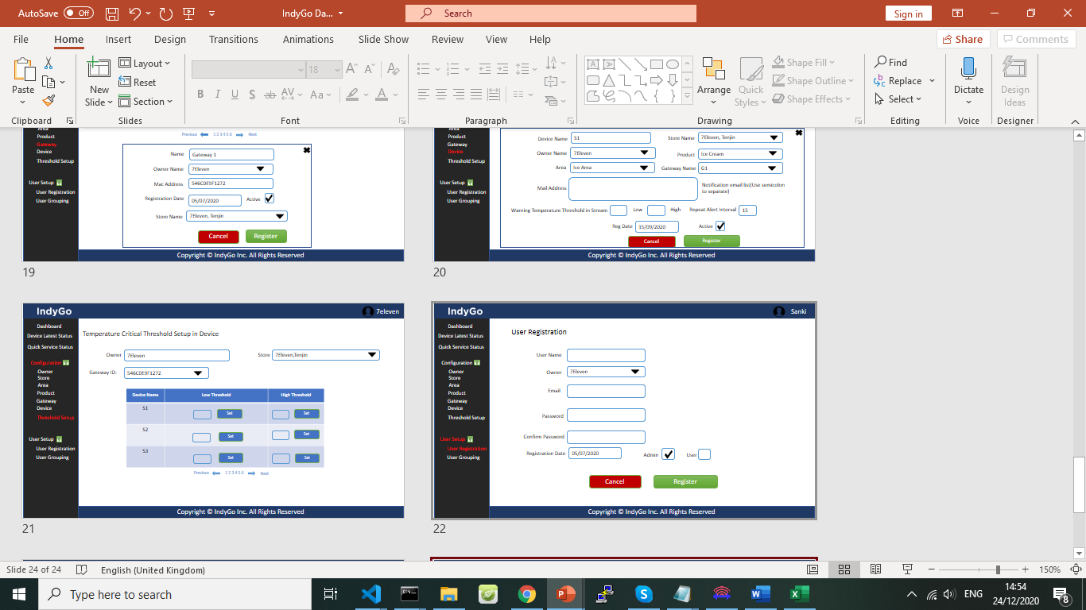
20. Device 21. Threshold Setup
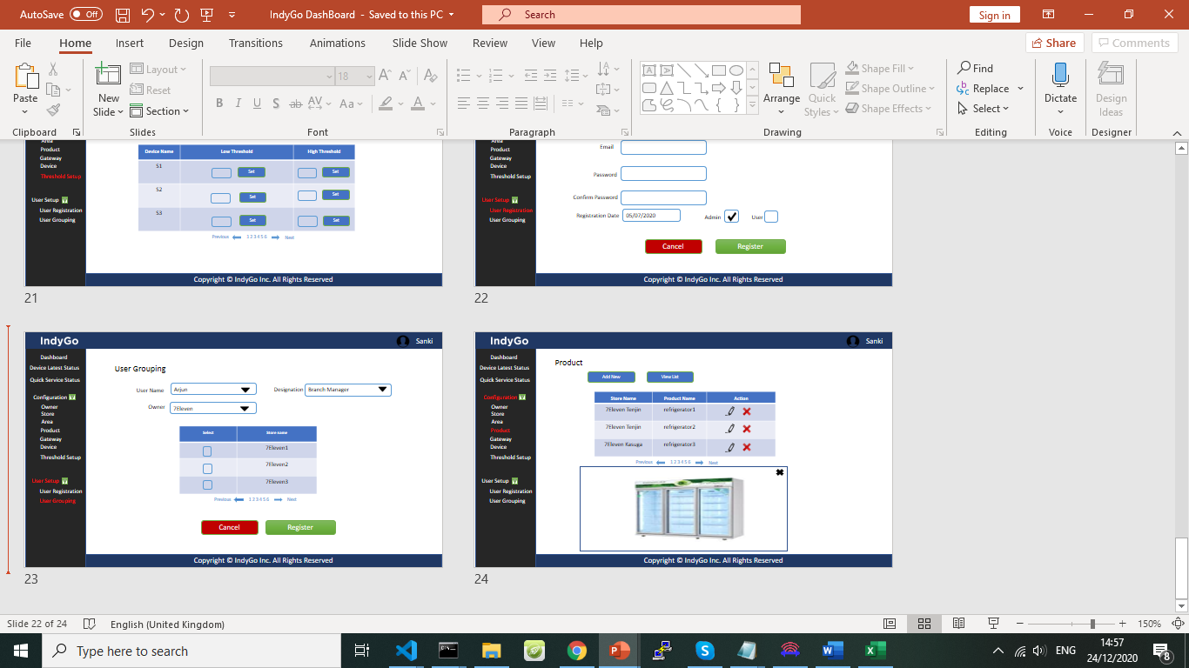
22. User registration 23. User Mapping
24. Product Image upload
4. Technical architecture

Software | Description | Version
Amazon Web Services | Cloud computing platform | Ubuntu 18.04.5 LTS (GNU/Linux 5.3.0-1035-aws x86_64)
MongoDB | Database | Mongo Server version 4.4.1
Bootstrap | UI Framework / Theme
Node / Node.js | Programming Language | v11.15.0
AngularJS | Programming Framework for Web UI
SMS Api | Nexmo / Vonage

5. Database Sizing

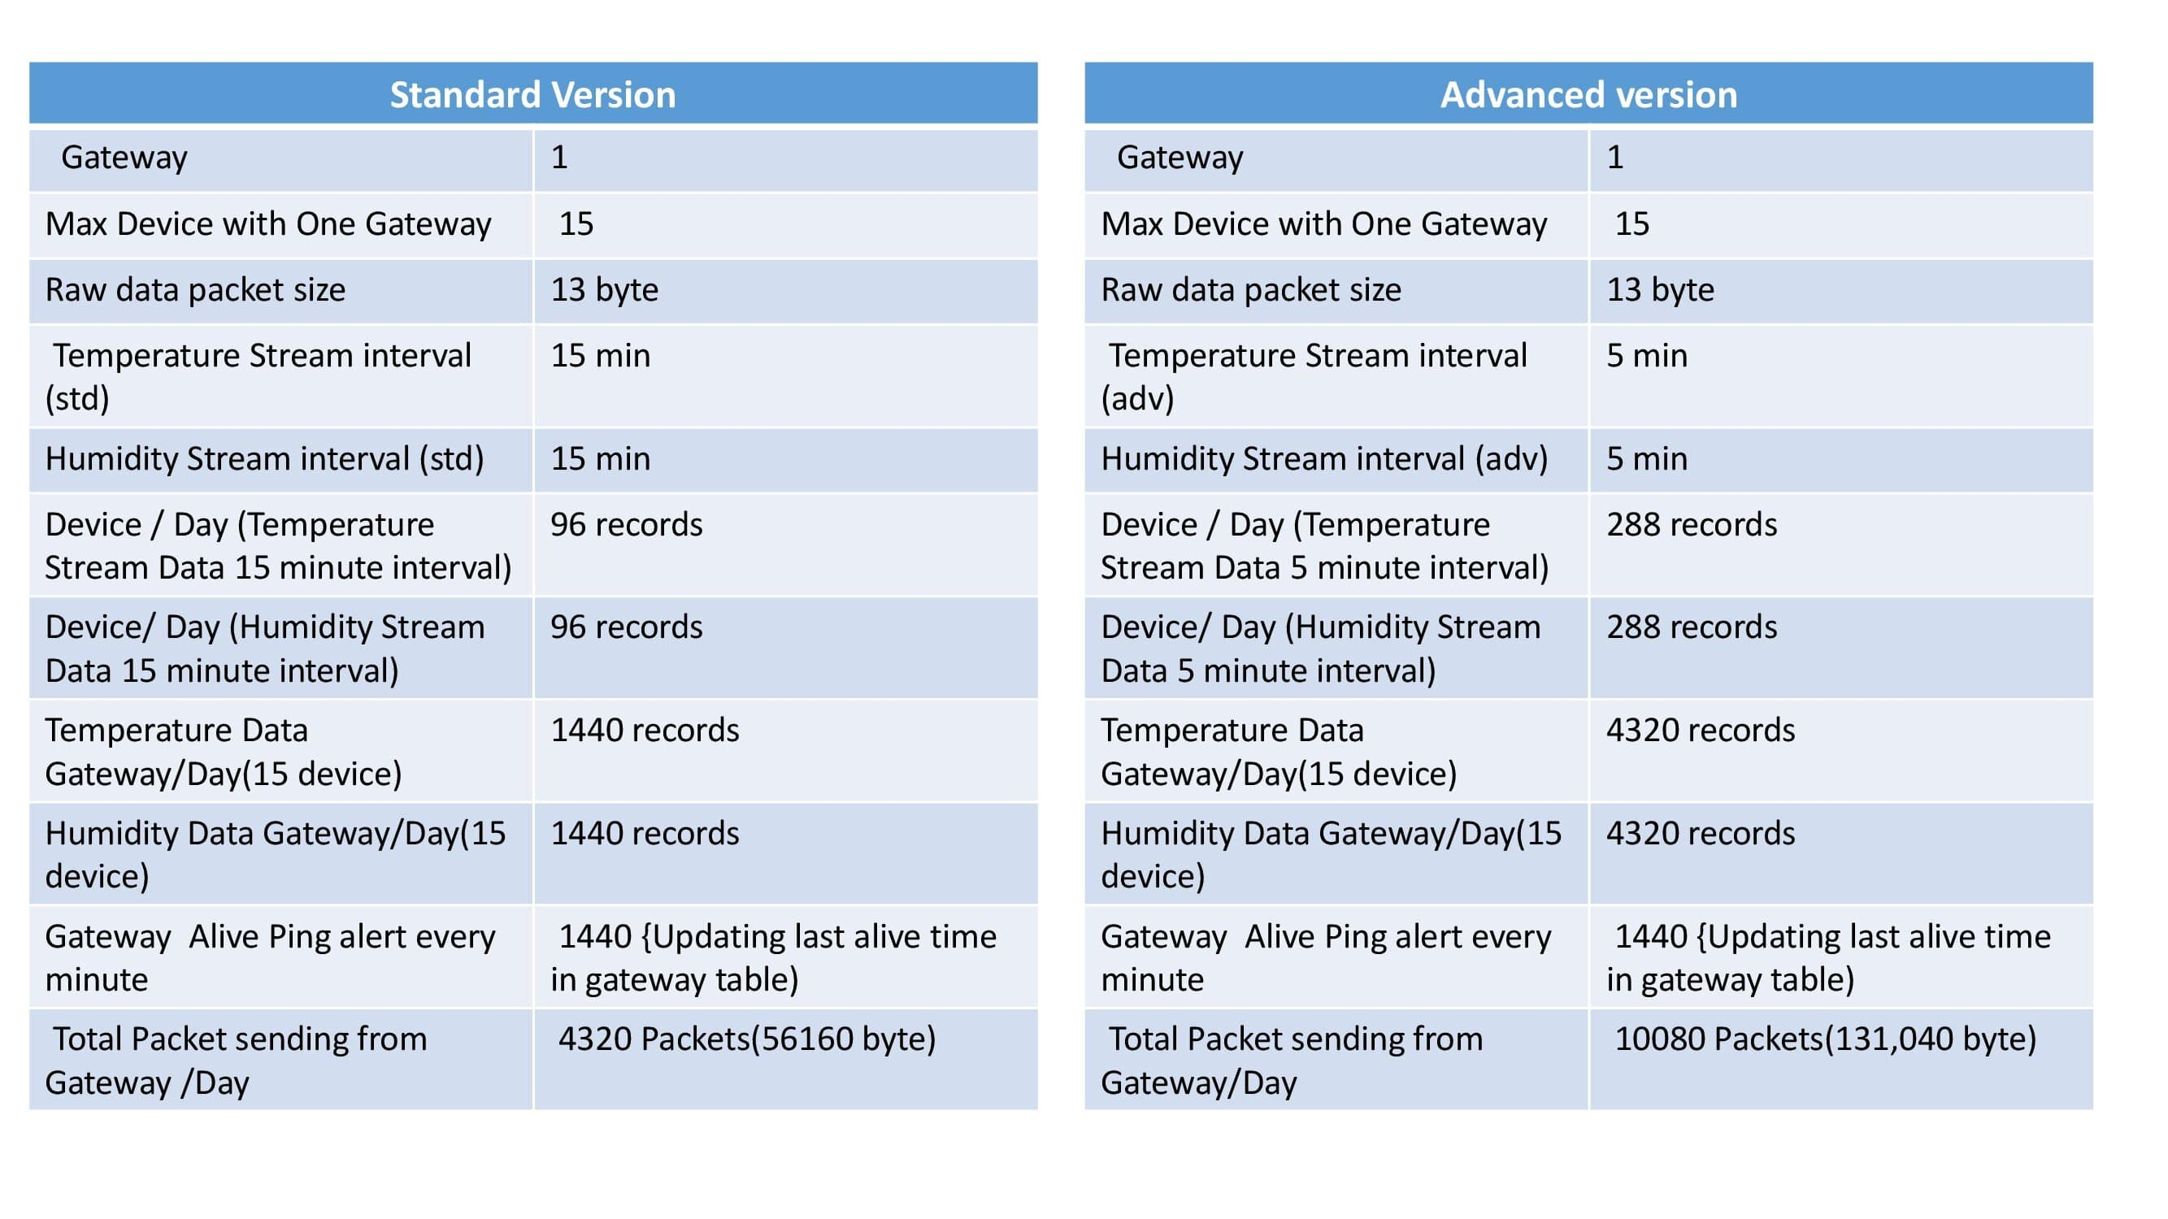

- Database Size a Store (1 gateway,15 devices) with 2 years of Data (Approximate)

Standard Version | Advanced Version
1.5GB | 2.5 GB

6. Detailed Solution

